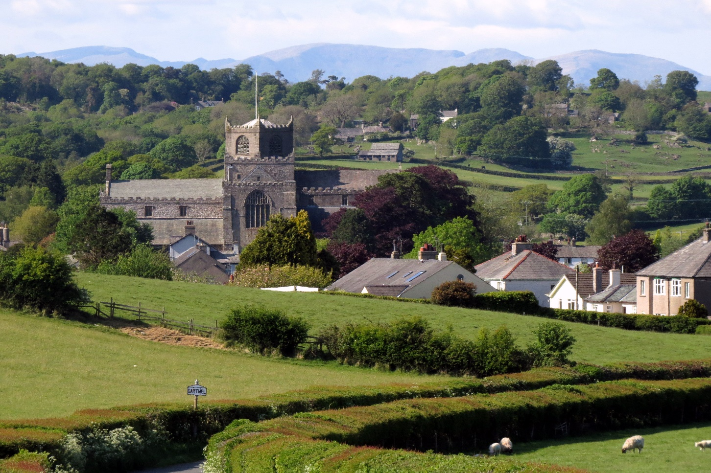

**COMMUNITY PLAN**

**ALLITHWAITE AND CARTMEL PARISH COUNCIL**

**2018 - 2023**

**MCL Nov 20**

**ver. 4**

**CONTENTS**

|  |  |  |  |
| --- | --- | --- | --- |
| **Section** |  | **Subject** | **Page** |
|  |  | Foreward | 4 |
| 1 |  | Introduction | 7 |
|  | 1.1 | What is the Community Plan? | 7 |
|  |  |  |  |
| 2 |  | Our Community | 8 |
|  |  |  |  |
| 3 |  | Environment | 11 |
|  |  |  |  |
| 4 |  | Survey Results (2012) | 14 |
|  | 4.1 | Business, Employment and Tourism | 15 |
|  | 4.2 | Children and Young People | 15 |
|  | 4.3 | Character and Environment | 15 |
|  | 4.4 | Communication | 15 |
|  | 4.5 | Health, Welfare and Housing | 15 |
|  | 4.6 | Sport and Leisure | 15 |
|  | 4.7 | Traffic Management | 17 |
|  |  |  |  |
| 5 |  | Background | 16 |
|  | 5.1 | Local Amenities and Services | 17 |
|  | 5.2 | Public Transport | 17 |
|  | 5.3 | Faster Broadband | 17 |
|  | 5.4 | In General | 18 |
|  | 5.5 | How healthy is the Parish? | 18 |
|  | 5.6 | How do people access services? | 18 |
|  |  |  |  |
| 6 |  | Planning | 18 |
| 7 |  | Issues and Priorities | 20 |
| 8 |  | Transport and Accessibility | 22 |
| 9 |  | Recreation – Sport and Leisure | 24 |
| 10 |  | Community Services | 25 |
|  |  |  |  |

|  |  |  |
| --- | --- | --- |
| **Appendix** |  |  |
| 1 | Action Plan 2018 - 2023 | 26 |
| 2 | Achievements - Community Plan 2013 - 2018 | 34 |
| 3 | Next Five Years 2018 - 2023 | 36 |
| 4 | Consultation Process | 39 |
| 5 | Acknowledgements | 40 |
| 6 | Contacts | 41 |
| 7 | Maps – Allithwaite and Cartmel | 42 |

**FOREWORD**

The Community Plan was published in 2013 following the most ambitious consultation exercise undertaken by the Parish Council in decades and now the Parish Council are reviewing and updating the plan in light of current developments. A great deal of what we set out in the Community Plan has been achieved (Annex 2) or is ongoing.

As a result there is a need to decide where any further activity should focus (Annex 3). When the last plan was undertaken residents and businesses identified key priorities the parish. After five years it is possible that such priorities have now changed and our communities may wish to see a different focus on how we shape the future of our villages.

As its title suggests, the community as a whole owns the Plan, even though the Parish Council launched the idea. During the review process there will be regular updates in the Westmorland Gazette and Grange Now, plus in the Parish Council’s monthly Newsletter. In addition the Parish Council’s website will be regularly updated – [www.allithwaiteandcartmel.co.uk](http://www.allithwaiteandcartmel.co.uk).

Though it is a snapshot of the public’s attitudes, values and concerns, many of the Plan’s aspirations have been long-standing ones. The intention is that the comprehensive process which produced the Plan has added value to its findings, helping persuade our key partners to support the parish’s prime objectives.

There are high levels of satisfaction with living in the area. The community is clear about what it values here. The local countryside should be preserved from intrusions such as significant housing development. The villages should not become even more commercialised. The community needs to remain vibrant with young families continuing to live here.

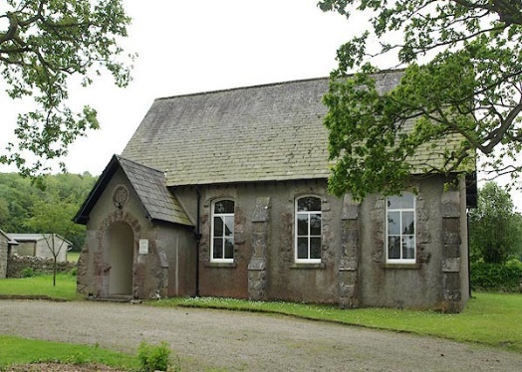Most of the issues, as might be expected, are not new but have become more important with the growth of the population within the area, bringing increased pressure on the infrastructure of our rural parish. This will continue with the demand for more housing and the impact of plans for the expansion of the local area.

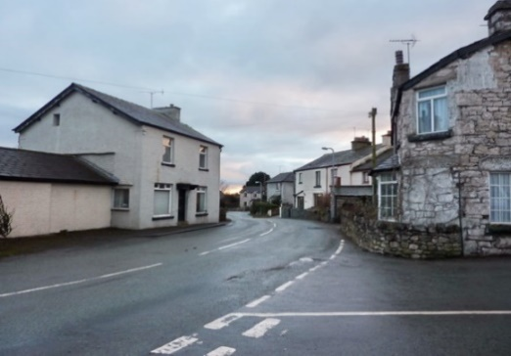

We need to be prepared to achieve the best possible outcome to the inevitable proposals for change and its consequences; seizing the opportunities for improvement and objectively opposing the threats to the character and sense of place that we value as residents.

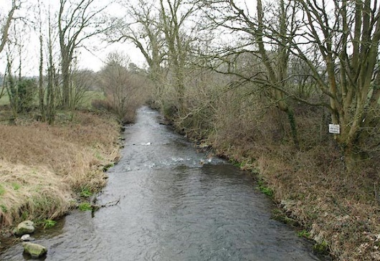

Issues to be addressed include road traffic, safety and parking, gritting of roads and pavements, public transport provision and the quality of broadband. The need to attract visitors is well understood and local events are popular, but they should not increase beyond their current level.

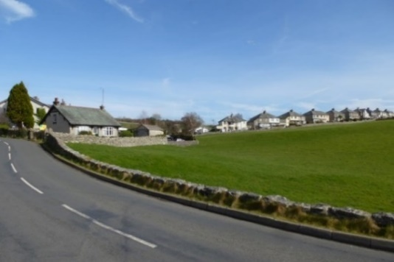

There is strong support for affordable housing and local occupancy, particularly for people connected with parish, but any housing development should be in keeping with the locality and small scale.

Public open spaces play a vital role in the social and economic life of communities they can be a particular and distinct resource for young people looking to socialise with others.

Green spaces should be fully accessible to the whole community, for example, a community garden, a community allotment or a wildlife area (Quarry). It is a place that the community is fully involved with from its design and creation to its management and maintenance. The benefits can be numerous and vary depending on the type of project.

The community plan, we hope, will enable residents to have a place for leisure and recreation, and in developing activities that enhance community spirit and inclusion.

**Our Vision**

It is clear that our communities have very high aspirations in seeking improvements to the places in which they spend most of their lives. We want our villages to be much better places in which to live, work, study and play in.

Our residents want the best facilities possible for our children, young people, elderly and other vulnerable groups. We want people to be safe and potential threats to safety dealt with. Our residents want to see the development of conditions in which businesses thrive in a vibrant centre and want new opportunities for jobs and training to develop new skills.

We want our children to have the best possible schooling. We want sufficient, affordable housing to meets the needs of the Parish but equally want to see the villages developed in a way which is in character with their roles and scale. We want to ensure that community facilities that are necessary are provided.

Finally we want more things to do and require all community facilities to remain open and improve. Above all we want to be a sustainable community.

This aim is at the centre of the Parish Council's work. In addition to the support of residents we need people to become actively involved as councillors. My hope is that the Plan will inspire more residents to see the value of making a direct contribution towards its realisation.

Mike Lamb

Chairman – Allithwaite and Cartmel Parish Council

November 2018

**1. INTRODUCTION**

The Allithwaite and Cartmel Community Plan was published in 2013, the Parish Council have now updated the plan to cover the period 2018-2023.

**1.1 What is the Community Plan?**

Communities everywhere are constantly changing and the government wants communities like ours to take more control of our own lives, to say what we want done in our own neighbourhood and to engage with other organisations to get it done. We cannot and should not prevent change, but we can influence the way it happens and is managed, preserving all that is good and serving the future needs of the residents. It is an opportunity for all in our community to express their views.

Community Plans are a non statutory documents are more to do with the provision of services and setting Parish Council priorities. Allithwaite and Cartmel Parish Council’s Community Plan was ‘adopted ‘in 2013. The Community Plan is a document which will aid Allithwaite and Cartmel Parish Council to deliver its priorities, deliver its services and carry out its responsibilities over a ten year period, from September 2018 to August 2028. The Community Plan has been produced on the basis of listening to the views of the community. The Plan has developed priorities as part of the community engagement. It includes both policies and proposals. It replaces the original Community Plan which was approved back in 2013.

Within the Plan are a number of planning policies which will be used by the Parish Council to respond to consultations on planning applications and other planning proposals. The plan is not a statutory planning document and the Local Planning Authority remains South Lakeland District Council which are the consulting authority. However, the established policies with assist in informing the community and developers alike as to what likely stance the Parish Council will take where planning proposals come along.

The proposals within the Parish Plan are expanded upon in the Action Plan that accompany the main document. These give details of the steps that will be taken to achieve the proposals and include details of who will be responsible for delivering them.

**The Community Plan should:**

* be comprehensive, considering all aspects of local life including social, economic and environmental issues of concern to our community;
* involve the whole community; everyone should have a chance to have their say and get involved in the Plan;
* be based on information provided by the community participation, surveys and research. involve Local Authorities with the process;
* be focused on creating an action plan with a clear statement of Who? What? Why? and How?

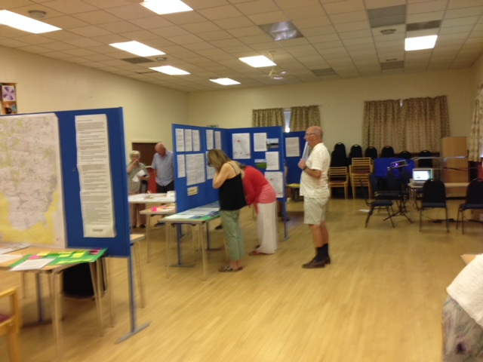Over the years a number of snapshots have been taken of life in the parish to identify issues of greatest concern to local residents. In 1993, based on an extensive consultation exercise, Allithwaite and Cartmel Parish Council published Village Appraisals for both Allithwaite and Cartmel. In 2009 a Parish Statement was produced, setting out the public’s most important priorities for action.

Government policy has been to encourage Parish Councils around the country to develop fully fledged Parish Plans. Often known as community led plans these were to be ‘owned’ by the community and intended to help Parish Councils focus on agreed local priorities.

In October 2010 the Parish Council set up a Community Plan group to move this idea forward. The group consisted of Parish Councillors and members of the public who for the most part represented particular community groups or interests. Informal consultation exercises were undertaken with the local community throughout the following year, resulting in an exhaustive compilation of issues. These at the right time formed the basis of a detailed questionnaire for every household in the parish.

The questionnaire was distributed door to door and made available online late spring 2012. This was the process by which public opinion across the full range of local issues could be both identified and quantified. Much detailed analysis has followed, together with further public consultation at the action planning stage. The present Community Plan (2013) was the outcome which is now being revised.

**2. OUR COMMUNITY**

Allithwaite and Cartmel Parish forms a rough arc midway across the Cartmel peninsula, which lies to the south of the A590 in south Cumbria. It is located between the Lake District National Park and Morecambe Bay. The parish comprises the villages of Allithwaite and Cartmel with surrounding rural areas. It has 907 households and a population of approximately 1,831. The Core Strategy, which underpins South Lakeland District Council’s Local Development Framework, identifies Allithwaite and Cartmel as local service centres. They are situated in close proximity to the resort of Grange-over-Sands, a key service centre.

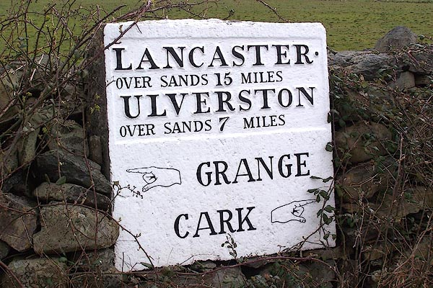The area’s transport links include a railway station at Grange, bus services to the local towns and the M6 approximately 15 miles away. Grange offers a range of shops, while the larger towns of Lancaster, Kendal and Barrow-in-Furness can be reached within 30 to 45 minutes’ drive.

The traditional economy of the area has been mainly agricultural with some small businesses. Tourism now plays a major role and there are consequently numerous related accommodation, catering and retail businesses in the parish.

The Cartmel Conservation area is an asset to the Parish. The conservation area includes not only the two separate built up areas that form the settlement but also the immediate landscape setting around the village to the north, south, and west, as well as a narrow corridor of meadow land which separates the two discrete areas.

A large proportion of Cartmel village is situated within high probability flood risk land relating to the River Eea and minor tributaries.

Cartmel is renowned for its historic priory and race meetings and the valley as a whole enjoys unspoilt views extending as far as the Lake District fells to north and west. The village’s rich built heritage is reflected in its conservation area status. The District Council’s Core Strategy aims to ‘secure the preservation and enhancement of the very distinctive character and appearance of Cartmel village and ensure that its characteristic landscape setting is protected from harmful development’.

Holker Hall, located in the neighbouring parish, owns a significant proportion of the land locally including various farms, woodland, and Cartmel Park (the racecourse, situated on the edge of Cartmel village). Over recent years Holker Estates has extended the number and range of events held at the racecourse.

Allithwaite is a south-facing village attractively sited on low hills that overlook Morecambe Bay. The village is less dependent on tourism as a community, though it has features of interest such as Boarbank Hall and walking in the area is a popular leisure activity. Nearby large scale events do have an impact on the locality. The village has continually grown in size over the last fifty years and has more households than Cartmel. While it has fewer historic properties, the nature of its physical development nevertheless presents its own challenges to its residents.

Changes in the pattern of the parish’s population over the last 30 years have seen an increasing number of people moving from outside the area to live here, some of them commuting to employment and many of them retired or second home owners. In Cartmel particularly increased homes are being bought for use as holiday lets or overnight accommodation linked with local eating establishments.

The number of permanent static vans and chalets in year round holiday parks has also increased. The area’s popularity with visitors has had a significant impact on the market value of local housing and therefore on the availability of affordable homes for local residents. The Core Strategy (SLDC) has set a target that 35% of new dwellings in the area are affordable.

(Data – 2011 Census)

Despite increasing numbers of non-main residences, both villages still enjoy a thriving community life. While some leisure activities tend to be focused on Cartmel, with its range of eating establishments, the Priory, park and village hall, Allithwaite has its own sports field and pump track, community centre, King George V playing fields for younger children and Orchard, all of which provide venues for a wide range of clubs and social events.

Both villages have shops, pubs and post office facilities. They both have successful primary schools and Cartmel has an 11-16 comprehensive school, to which pupils travel from a wide catchment area. Cartmel also has a doctors’ surgery with a dispensary.

Having adopted the Community Plan in 2013, Allithwaite and Cartmel Parish Council was committed to promoting and developing the aims, objectives and actions outlined in the Action Plan. It has taken measures to manage its budget and resources in the delivery of the Plan and has kept residents informed about the progress made. The Action Plan provides a transparent framework which enabled regular monitoring to take place.

While the Parish Council will have the overall management and control of the delivery of the Plan, it will seek the support of various groups in the community to deliver different aspects of it. The Parish Council will need to commission some new groups alongside existing groups:

* Allithwaite Community Group.
* Active Travel group.
* Countryside group.
* Cartmel Township Initiative - CTIDG.
* Cartmel Environment Action Group - CEAS-G.

A number of members of the public have already volunteered their services to support the Action Plan in some capacity. The Parish Council intends to follow up such offers as well as further canvassing local people to ensure the viability of each group.

The Parish Council will provide a clear brief which outlines the delegated powers of these groups, the timescale within which it will work and the success criteria which will be applied. Where groups exist already the Parish Council will similarly define its expectation in negotiation with them.

All groups will be expected to report back to the Parish Council on a regular basis as well as producing a summary statement of progress for the Annual Parish Meeting.

**3. ENVIRONMENT**

A questionnaire was conducted in 2012, and the results fed into the production of the original Community Plan for the Parish in 2013. The frequently voiced message was one that in the future that the area and the villages would stay the same. On the whole respondents appreciated how their village looked, and the surrounding countryside was as much if not more important.

284 questionnaires were completed. 64% of respondents were aged 51 or over. 69% had lived in the area for at least 11 years. Given the length of the questionnaire some people did not answer all questions.

The profile of respondents overall showed little variance across the parish. The majority were in the older age ranges, 87 (31%) being between 66 and 80 years old and 94 (33%) between 51 and 65. 32 were over 80. 48 were in the 36-50 group and only 9 respondents were younger than this. 137 (48%) admitted to being male, 122 (43%) female.

The major environmental issues addressed in the Parish Plan Questionnaire covered the following issues:

* The Development and Infrastructure of the Parish in the context of preserving the character of the area.
* Issues surrounding the safety and living environment of residents.
* Community activities in the context of whether land or facilities in the Parish could be used more effectively for such purposes.

(Data – 2011 Census)

There was a high levels of satisfaction with living in this area. Repeatedly respondents commented on the quality of the countryside, its scenery and its peace and quiet. Equally they valued the nature of the community itself and the quality of village life including its relatively crime free nature.

The most frequently voiced hope for the future was that the area and the respondent’s village would stay very much the same. Where change was necessary, it should be for such things as improvements in parking and provision of affordable homes for local families.

The local countryside should be preserved from intrusions such as significant wind farm development and the villages should not become more commercialised than they are. The community needed to remain vibrant with young families continuing to live here.

The main issue related to the extent and nature of housing development within the Parish and the questionnaire revealed that a majority felt that there had been too much housing development, with an even greater majority considering that those houses that had been built were too big or too expensive.

Almost all the respondents (268 or 94%) have lived in the area for two years or more, with 196 (69%) having been here at least 11 years. 71 (25%) have lived here 30 years or more. There were 12 second home respondents (4%), while 14 people did not answer this question or preferred not to say.

(Data – 2012 Parish Questionnaire)

The Census Statistics for Allithwaite and Cartmel indicates that the Parish has a resident population of 1,783 in 2003 and 1,811 in 2011. There is higher proportion older residents than South Lakeland, and England 31.5% of the Allithwaite and Cartmel population were aged 65+ years and older compared to 24.2% in South Lakeland and 16.3% in England.

(Data – 2011 Census)

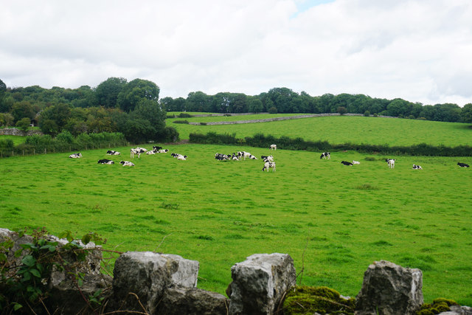

Allithwaite and Cartmel has a relatively high proportion of detached houses (45.5% of dwellings compared to South Lakeland, 30.8%) and a low proportion of flats (6.0% of dwellings compared to South Lakeland 15.6%. 83.2% of households in Allithwaite and Cartmel are owner occupied, compared to 73% in South Lakeland, with 5.7 of households being social rented accommodation compared to 10.7% in South Lakeland.

(Data – 2011 Census)

In terms of transport and accessibility, households are very reliant on private cars with 90.9% of households having 1 car or more compared to 84.7% across South Lakeland.

The villages are served by the Furness railway with stations at Cark and Kents Bank being within 2-3 mile of each village. The bus service is more intermittent and does not facilitate most journeys to work.

**4. SURVEY RESULTS (2012)**

There were a number of strong themes playing in all our research, both in the outcomes of the questionnaire and in the various consultation which we undertook with our public events.

Clearly there were high levels of satisfaction with living in this area. Repeatedly respondents commented on the quality of the countryside, its scenery, and its peace and quiet. Equally they valued the nature of the community itself and the quality of village life including its relatively crime free nature.

**4.1 Business, Employment and Tourism**

People greatly value our retailers, pubs and catering establishments and see it as important that they are strongly supported.

**4.2 Children and Young People**

The main view was that while facilities for under 12s were good or very good, those for young people were lamentable. Although there are some sporting facilities and clubs within the Parish, many youth members feel there is a lack of a suitable range of facilities where they can meet others informally and play casual sports with friends, rather than in a team. Opportunities for informal social contact are important for the young people in our Parish who attend a number of different schools and colleges within the area.

**4.3 Character and Environment**

There is a strong view that the Parish should not expand beyond the present settlement policy boundary. There are concerns that further development will be forced upon the Parish by SLDC.

**4.4 Communication**

A recurrent theme across all groups was the importance of improved communications within our community. We need improvements both in our communication media and in awareness of communication techniques within our organisations.

**4.5 Health, Welfare and Housing**

The Parish is fortunate in having a very high quality health centre in Cartmel. In general older people are well catered for and value the services and facilities available to them. A significant proportion of our retired community are active in the village and many services and organisations are dependent upon them to stay viable.

**4.6 Sport and Leisure**

The village has a variety of leisure organisations and facilities but many residents are not aware of what is available. A number of new activities, eg: Pump Track, have started as a result of the planning process. The chief thrust is to concentrate sports facilities for young people and to provide good storage and changing facilities.

**4.7 Safety, Security and Emergency Services**

Despite the very low level of crime statistics there is still a strong view that crime is a serious issue in the village and that antisocial behaviour is a problem. There are concerns about response times by the police and the other emergency services.

**4.8 Traffic Management**

There are serious concerns about road safety within BOTH villages. A series of public consultations specifically on this issue (Cartmel Township Initiative) identified actions to improve safety for pedestrians and for parking. Parking is a problem and more public parking is needed - not easily achieved.

**5. BACKGROUND**

The most frequently voiced hope for the future was that the area and the respondent’s village would stay very much the same. Where chang**e** was necessary, it should be for such things as improvements in parking and provision of affordable homes for local families. The local countryside should be preserved from intrusions such as significant development and the villages should not become more commercialised than they are. The community needed to remain vibrant with young families continuing to live here.

On the whole respondents in 2012 appreciated how their village looked and how its buildings were cared for. However, one criticism was pavement clutter, including ‘A’ boards. Open spaces within the villages were greatly valued with respondents stating such spaces were important. The surrounding countryside was if anything even more important to people.

As regards green issues, although major infrastructure projects were strongly opposed, interest was nevertheless expressed in smaller scale local renewable energy development: 54% of respondents felt this was very or fairly important. There was quite a strong demand for improved recycling arrangements.

Respondents viewed road traffic (57%), parking (53%) and safety (39%) as serious concerns, which were very much intertwined. These issues particularly affected the centre of the villages but also, to an extent, the wider area. The volume and speed of traffic were a concern and a reduced speed limit, particularly within the villages, was the most supported of the presented options.

Car parking was a significant problem, although this has been addressed in Cartmel but is still a problem, especially in the centre of the villages, where pedestrians felt particularly vulnerable. It is a daily issue and it applies all year round. Indiscriminate parking was one of the main bugbears. A range of solutions was supported, the most popular being additional parking provision on the edge of the villages.

Housing was a burning issue. It was felt that any housing development should be small scale: 57% were in favour of just 1 to 3 houses, whereas just 9% would support developments of 10 or more. On the other hand, the great majority of respondents showed strong support for affordable housing, 75% regarding this as very or fairly important. 71% of respondents supported the principle of building for local occupancy, particularly for people connected with the parish.

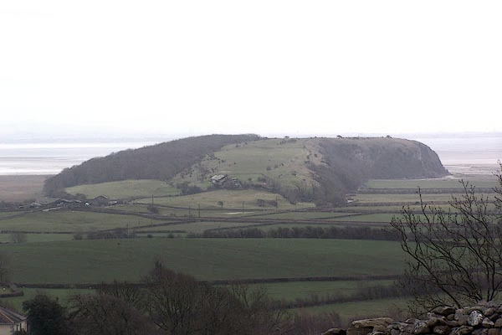

(View – Humphrey Head)

The value of having local businesses was recognised and the importance of attracting visitors and tourists was understood. Local events were popular and well supported, ranging from small community based events to the larger scale shows, festivals and race meetings. The vast majority of people felt the number of events should not increase beyond the current level, concerns being expressed by some about noise and, more significantly, road congestion.

**5.1 Local amenities and services** were generally well thought of. However, the gritting of roads and particularly pavements was regarded as unsatisfactory by a majority of respondents: 39% were satisfied against 45% dissatisfied with road gritting; and just 13% were satisfied against 54% dissatisfied with pavement gritting. A narrow majority thought road maintenance satisfactory. Many people were unhappy about dog fouling (32% satisfied with the situation compared with 40% dissatisfied).

**5.2 Public transport** – especially the bus service - was poorly rated to the extent that 18% of respondents said there was nothing which could induce them to use it more often. 70% regarded it as easier to use a car and 25% even though it easier to walk or cycle than use public transport. Services running at times needed (for example, for getting to work) and with better connections would help.

**5.3 Faster broadband** was supported by 75% of people, 46% seeing this as very important.

**5.4 In General** there is a feeling that the needs of particular groups in our community are at least reasonably well cared for, though quite large numbers chose not to offer a judgement. 52% of people were satisfied with how older people are cared for compared with 6% dissatisfied. For families the breakdown was 39% as against 5%, for people with disabilities 26% as against 10% and for younger people 26% as against 17%. A variety of suggestions was offered for improving the picture, including the views of young people from the local primary schools and of a small number from Cartmel Priory School.

**5.5 How healthy is the Parish?**

Health is a fundamental determinant of quality of life, having a direct impact on an individual’s ability to live a fulfilling and enjoyable life and also indirectly impacting on their ability to sustain standards of living through income. Ill health may also have a severe effect on other people, either directly through changing relationships (for example forcing people into informal unpaid care), or through indirect effects such as change in household income.

**5.6 How do people access services?**

Access to services is a major factor in quality of life for people in rural communities, where lack of transport can be a primary cause of social exclusion.

People are at risk from social exclusion where necessary services such as hospitals, education, employment and training centres, or food stores, are not easily accessible. This is especially likely to present difficulties for people without cars or who are unable to drive, whose mobility is limited, and in areas where public transportation is poor.

**6. PLANNING**

**The status of the Community Plan and National Planning Policy Framework**

Allithwaite and Cartmel is an area of great landscape and beauty. Farming provides the landscape and the landscape provides a thriving tourism industry. The local heritage is what gives a place its character. The existing built environment and local heritage are often forgotten elements when it comes to development. The built and historic environment should be conserved and where possible enhanced for future generations to enjoy the beauty.

The planning framework in the country is in the state of change as the new government has different ideas about how the planning system should operate. The system will change in the life of the Community Plan, and this may need further changes in the law. This change is likely to result in a less regulation but where local communities potentially have a bigger say in what happens where.

The Government want the planning system to be less burdensome to developers and are committed to ‘a presumption in favour of sustainable development’. They have also introduced legislation, largely through the Localism Act, about local communities producing their own ‘neighbourhood plans’ (currently in progress) and choosing, for example, what sort of housing should go where.

Allithwaite and Cartmel has distinct character, form and quality. The design of new development should be within the context of the Allithwaite and Cartmel unique features and characteristics, responding appropriately to its historic setting and supporting the evident sense of community. The design of any new development should therefore be complementary to Allithwaite and Cartmel, drawing upon, and inspired by, the Allithwaite and Cartmel villages individual assets.

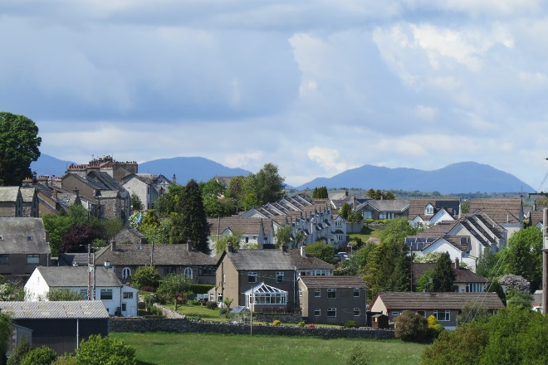However, such plans would still need to meet Government Guidelines and they would be subject to significant challenge before they could be adopted.

SLDC is the authority that determines planning applications taking account of a range of material planning considerations. The Parish Council does not have any planning powers.

The Parish Council is a statutory consultee and SLDC must, therefore, consult the Parish on planning applications.

There are 96 listed buildings within the parish of Allithwaite and Cartmel. Any development proposal that may affect a listed building or its setting should preserve the special architectural or historic interest of the building and its setting embodied within Allithwaite and Cartmel.

Green infrastructure is important to underpin the overall sustainability of a development by performing a range of functions including flood risk management, the provision of accessible green space, climate change adaptation and supporting biodiversity.

The Parish Council, who come to their own view on proposals, present views on applications for the benefit of the whole Parish. There is no particular weight given to the Parish Councils view’s when applications are considered.

**7. Issues and Priorities**

The initial community engagement events showed that while general issues were the same in both villages there were different scales of effect and different priorities for addressing them. This section of the plan looks at the results of the household questionnaire which has been used to develop the action plans which are set out and summarised in the next section.

On the whole respondents appreciated how their village looked. 45% did not think there were any unsightly areas or features needing improvement compared with 35% who did. However, there was criticism of pavement clutter, including ‘A’ boards.

Litter and dog fouling was a problem in certain places. Allithwaite people were unhappy about unkempt pavements and grass verges and parking was seen as an issue in Cartmel, this issue has been addressed by the Cartmel Township Initiative.

Most people felt that alterations or repairs to buildings were in keeping with the village tradition (51% compared with 16% who did not) and that older or more historic buildings were well looked after (57% against 7%).

A number of Allithwaite respondents felt there should be greater Parish Council involvement; and a number objected to developments like Greendales. People from Cartmel felt there should be greater enforcement and supervision of conservation area planning principles. Plastic or otherwise inappropriate windows and doors were mentioned frequently.

Allithwaite residents were interested in the idea of a square, ornamental park or other focal point for their village and this has been achieved with the Orchard and allotments. (31% of Allithwaite responses agreeing, the same number answering Possibly).

Cartmel people strongly approved the idea of a footbridge crossing the River Eea linking to the corner of the square beside the Kings Arms and this is currently on-going with the CTI. (46% Yes and 24% Possibly). However, they were rather more divided over a garden by the entrance to the racecourse car park (38% Yes, 22% Possibly). Both villages supported improving the provision of road or street name signs (33% Yes, 28% Possibly with 24% against the idea).

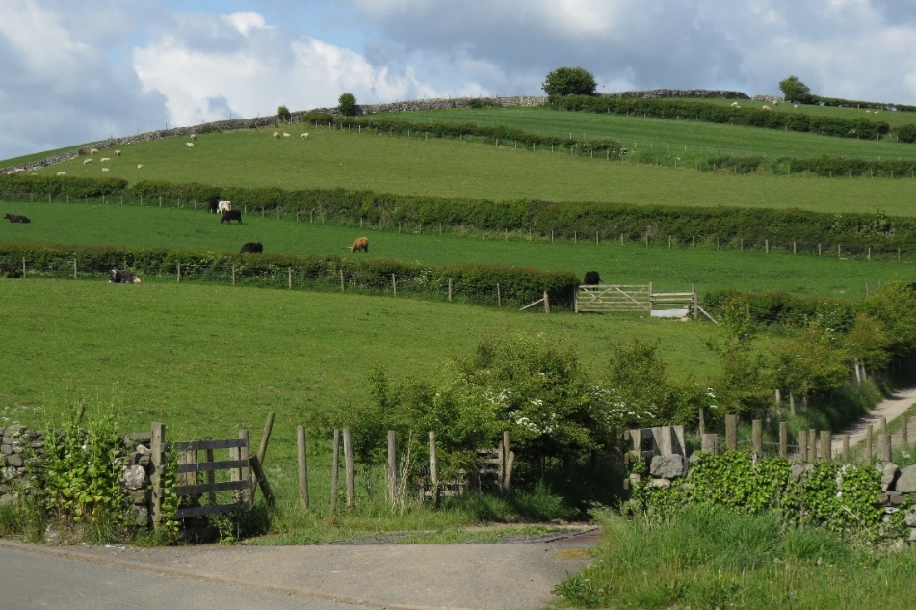Open spaces within the villages are greatly valued. 74% respondents said such spaces were very important and a further 17% fairly important. The surrounding countryside is at least as important to parish residents as the villages in which most of them live: 77% regarded it as very important and a further 14% as fairly important.

Walking was the most popular activity with 86% of people walking at least weekly and most of them daily. Apart from pure relaxation, which came second to walking, a variety of sports and other leisure activities was listed – cycling, gardening, horse riding, running and many more.

Various different open spaces throughout the locality were listed, including footpaths generally, Cartmel park and woods (mentioned by both Allithwaite and Cartmel residents) and Wartbarrow Lane and Fell (Allithwaite). The use of the community centre and playing fields are important village assets which are widely used.

Though major infrastructure projects are strongly opposed, there is some interest in smaller scale local renewable energy development, 23% of respondents seeing this as very important and 31% as fairly important.

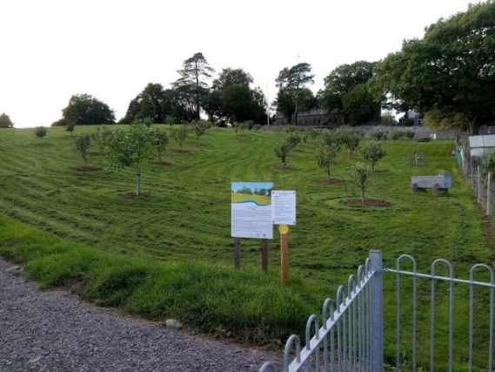More general responses showed residents open to a variety of green ideas: 116 people (41%) responded to the general question which asked for ideas for local initiatives. Of these, 48 felt there could be improvements of various sorts in waste recycling arrangements; 17 supported solar roof panel initiatives, including their installation on public buildings; seven suggested a greater emphasis on buildings insulation; six suggested small scale onshore wind energy, including community organised projects and three supported offshore wind. (Three others opposed wind development). Other suggestions included tidal energy, increasing the number of allotments and how to deal with litter.

A number of people considered it important to reduce the use of private vehicles by such means as the better provision of walking and cycle ways, improvements in public transport, improvements in the provision of amenities locally and better broadband.

**8. TRANSPORT AND ACCESSIBILITY**

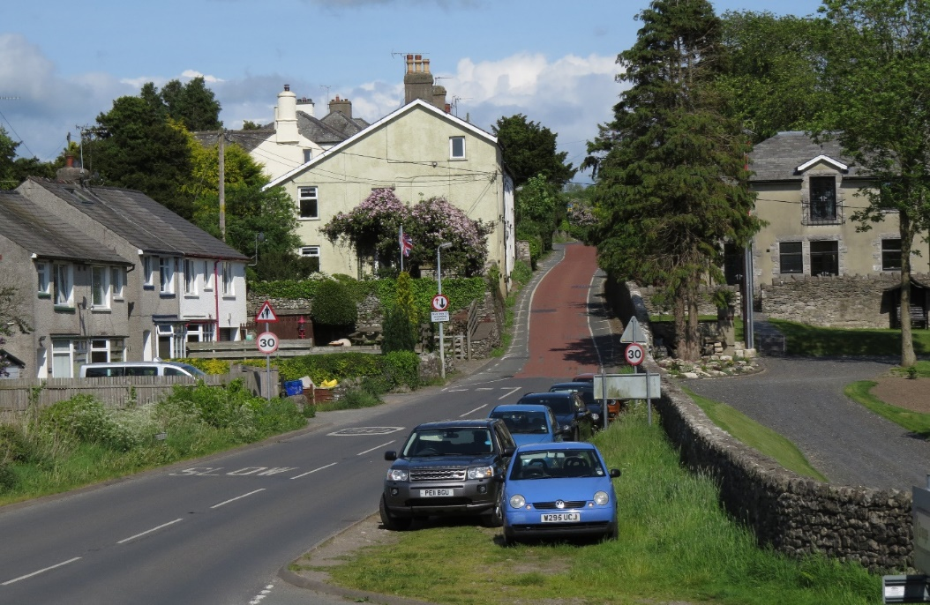Parking was seen as a significant problem. 53% of people confirmed this, the proportion being higher for Cartmel (62%). The problem was a daily one rather than particularly during holiday periods and related to parking in the villages (51% seeing this as a major or minor problem) rather than outside one’s home (a major or minor problem for 27%).

In both villages the combination of narrow roads and indiscriminate parking created real difficulties. Allithwaite respondents commented how parking both sides of the road could make it difficult for large vehicles to get through.

The school run was considered part of the problem.

The location most complained about in Allithwaite was Church Road, a particular difficulty for people wanting to park near their home. Despite these views, a number of respondents felt parking was not really an issue in the village but that the situation would be helped if homeowners who had a drive used it.

In Cartmel the problem was almost everywhere, however this has now been greatly resolved, but in the centre, where again indiscriminate parking make things difficult. The extent of parking by business owners and employees, unrestricted by any short stay regulation, was commented on; parked delivery vehicles were also a regular problem.

(Data – 2012 questionnaire)

Cartmel support for all the above measures was more positive than these overall scores, in many cases by 10 to 15%, though parking bays marked with white lines remained least popular. A number of additional comments from Cartmel respondents mainly reiterated the above points. Restricting street parking in some way was seen as a key solution, but such restrictions needed to be enforced. Some people, however, stated their opposition to yellow lines.

Allithwaite and Cartmel was designed before the car became the preferred mode of private transport and there were many comments about the lack of availability for car parking during the consultation process.

Traffic generally and road safety were both seen as problems besetting the area on a daily basis. The traffic situation was felt to worsen at weekends though holiday periods were not identified as an extra factor.

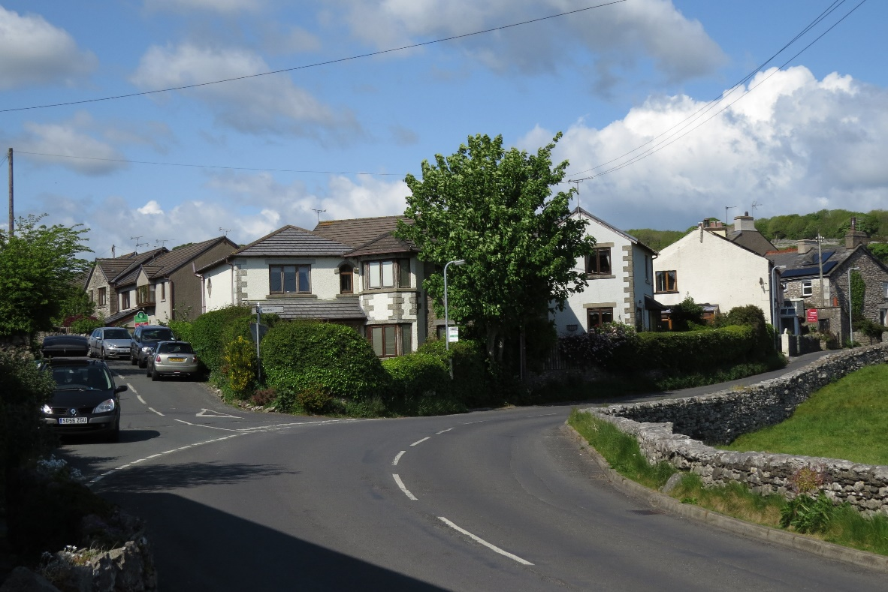

Traffic was seen as a problem by 57% of people and particularly so by Cartmel people (68%). It was a major or minor problem in the villages themselves for 61% (for Cartmel 78%). Almost twice as many respondents, across both villages, saw it as a major rather than a minor problem. In the wider area outside the villages it was felt to be a problem by 41% of people.

Fears over road safety were inevitably linked to the more general problem of traffic. It was a concern for both pedestrians and vehicle users. Though a number of people chose not to answer, 167 respondents (or 59%) regarded road safety as a major or at least a minor problem in the villages and 125 (44%) felt this to be so in the wider area.

In the villages part of the problem was seen as parked or speeding cars and the lack of pavements. In Allithwaite poor visibility was an issue, partly because of overgrown hedges. Large vehicles were thought dangerous in Cartmel village, as well as vans obstructing one’s view, but to an extent the problem was seen as sheer volume of traffic. A number of roads were named as being particularly prone to traffic problems in both villages, on the outskirts as well as in the centres.

In the wider area the general problem was fast traffic and too many large vehicles on narrow roads and lanes. All the roads out of Cartmel were mentioned. Wartbarrow Lane and the road down to Cartmel were particular problems for Allithwaite respondents, whose other concerns included blind corners and poor provision of passing places.

(Data – 2011 Census)

Of the suggestions proposed to improve the situation, a 20 mph limit in villages was by far the most popular (58% of respondents). Least favoured by far was improved street lighting (6%). Non-roadside pedestrian routes was a highly rated option across the parish (37%) and pavement improvements also gained reasonable support (28%) from both villages.

The increase in traffic has led to parking problems and perceived danger to road users and pedestrians. Lines of parked cars obstruct the free passage of traffic on Church road between the entrance of the school at the start and end of the school day; this also occurs if there are special events being held outside school hours.

It is clear that there is limited provision of and support for public transport, although there might be more interest if the present service were more frequent. Nevertheless, the present form provides a lifeline for those who are unable to drive or cannot afford their own vehicle.

One issue, which may take time to evaluate, would be an improved bus service, but substantial subsidies may be required.

**9. Recreation – sport and leisure**

The Parish has a number of recreational activities and facilities, ranging from sporting clubs to coffee mornings for the more senior inhabitants of the community. The Parish boasts two substantial halls, the Village Hall in Cartmel and the larger Village Hall in Allithwaite. There are recreation grounds, which include tennis courts, football pitch, pump track, orchard and children's playing field, in Allithwaite. Cartmel has a cricket ground, football pitch, racecourse and scout hut. The majority of the recreational activities are advertised in newsletters and on the website. They are also communicated through the Parish notice-boards, the local schools, post offices and the Church.

Many of these recreation events within the Parish only exist due to the wonderful community-spirited volunteers who give up their time to organise these events. There is an ongoing recruitment drive for more volunteers within the Parish and anyone interested can contact the Parish Clerk who will provide the necessary information or use the website where all societies and activities are listed with contact details.

The Parish also has numerous sporting teams representing a wide range of sports for different age groups. Some of the facilities need some investment to bring them up to modern-day standards. Despite the availability of clubs and team sports, there is a lack of facilities where youngsters can participate in sporting activities and the provision of a multipurpose court and Youth club would be a major step forward.

**10. COMMUNITY SERVICES**

The Parish has a friendly and thriving community life There is an impressive range of voluntary services and organisations, several associated with the churches, to assist with living in a rural area. Residents value their community and wish to see its appealing character maintained. The Parish is well served by its local schools, Post Office, Surgery (dispensing) and other retail outlets and services.

There are also clubs catering for a wide variety of interests and hobbies, using the local facilities: Cartmel Village Hall, Allithwaite Community Centre, the Churches, Schools and sports and recreation grounds. The high usage of the public facilities recorded in this plan shows the importance of continuing with their maintenance and improvement.

Communication within the parish is mainly through the monthly newsletter produced by the Parish Council which is distributed across the Parish. Other sources of information is the Westmorland Gazette and Grange Now (a free publication).

The Parish Council has notice-boards around the villages and the minutes and agenda for parish council meetings are published on the website.

There is a Parish News page on the [www.allithwaiteandcartmel.co.uk](http://www.allithwaiteandcartmel.co.uk) website, where organisers can note forthcoming events so that major clashes can be avoided where possible. The Schools also issue regular Newsletters and include items of general interest alongside school news. Many people walk the village regularly and contribute to the neighbourly spreading of both friendship and local news.

It is a vital that this aspect of the community be supported and maintained. Likewise our Churches, which are open every day with a regular pattern of Sunday and weekday services. Both churches are used by the schools and other schools in the area at Easter, Harvest and Christmas as well as for special services and events during the year. Both churchyards are open to provide a final resting place for parishioners and those with a local connection. These historic church buildings are well used and well loved, but do not receive any state funding and are therefore dependent on the whole community for survival.

The increasing popularity of village markets has been mirrored by the monthly Friday market (3rd Friday in the month) in Cartmel. There are many skilled local craftspeople and producers, who are encouraged to find an outlet for their goods and services closer to home.

**ALLITHWAITE AND CARTMEL COMMUNITY ACTION PLAN – 2018 - 2023 APPENDIX 1**

|  |  |  |  |  |  |
| --- | --- | --- | --- | --- | --- |
| **Issue** | **Aim** | **Objectives** | **Actions** | **Organisations** | **Steering Group Review** |
| 1a / 1b. Village and Open Spaces | To protect the build and natural environment for the continuing enjoyment of present and future generations | i. Create clean and tidy villages and surrounding areas.  ii. Reduce pavement clutter.  iii. Improve road surfaces and footpaths.  iv. Improve signage in and around the villages.  v. Raise public awareness of the Cartmel conservation areas built heritage. Protect the village from inappropriate changes to properties.  vi. Seek to protect green spaces within villages and the surrounding countryside from inappropriate developments.  vii. Protect and enhance existing levels of access to the local countryside.  viii. Seek to enhance and develop the village centre in Allithwaite. | PC to commission and fund programme of work to include litter, dog fouling, grass verges and road sweeping. PC to explore participatory budgeting with SLDC and CCC.  PC to develop voluntary code of conduct with traders and monitor with SLDC enforcement officer  PC to organise survey, identify improvements needed and work with CCC to prioritise a programme of work.  PC to commission and fund programme of work which will identify improvements needed to street signs and local directional signs.  Develop a conservation management plan for Cartmel  PC to commission interest group to:   * identify landscape, environmental, and wildlife features of significance * draft strategy for PC approval   Review existing CCC footpath document with view to improve provision.  Review permissive footpaths/public access areas and seek to persuade landowners to introduce/expand network where possible  PC to seek ideas and fund appropriate projects where affordable | Allithwaite Community Group/Cartmel in Bloom, SLDC and CCC  Cartmel Traders, SLDC  PC, CCC  Allithwaite Community Group/Cartmel Townscape Initiative,  SLDC and CCC  SLDC, PC, CCC  Cartmel Village Society, SLDC, PC.  Countryside Group to work with other statutory and voluntary bodies  Active Travel Group, CCC  Allithwaite Community Group | Cartmel – Community in bloom engaging with SLDC to support their work. Allithwaite lengthsman now appointed.  Most A boards found to be on cobbles which are not highways therefore little can be done but engagement and review needed  Work to be done in Allithwaite as part of highways. CTI proposals published and implemented.  CTI proposals for Cartmel implemented. Allithwaite work needs doing as part of highways project. Review already undertaken, awaiting CCC response.  New conservation document overdue needs chasing. CVS working with SLDC, report awaited from conservation officer.  Work has begun, this would be better placed in the neighbourhood plan. Allithwaite created Orchard for wildlife area with an Apiary. Quarry under review with H&S work undertaken.  Active travel group has made excellent progress – action plan and budget submitted to PC for work 2016/17. Quarry working party established with budget to improve access to Quarry. Stile repaired Humphrey Head and number of footpath signs.  Village orchard now open for public use. Small picnic area with table/seats in Orchard,3 seats repaired in Allithwaite and added 3 new seats across village. |

|  |  |  |  |  |  |
| --- | --- | --- | --- | --- | --- |
| **Issue** | **Aim** | **Objectives** | **Actions** | **Organisations** | **Steering Group Review** |
| 1c. Green Issues | To encourage the take-up of environmental initiatives appropriate to local community level. | i. Improve waste recycling arrangements.  ii. Encourage small scale renewable energy schemes which do not have a detrimental impact on the surrounding countryside.  iii. Meet demand for ground to grow own produce by increasing the number of allotments and suitable garden areas as needed  iv. Encourage greater use of public transport to reduce community’s carbon footprint | PC to lobby SLDC for earliest possible rollout of plastic and cardboard recycling.  PC to work with G&C LAP and CCC to maintain household waste recycling site  PC to draw up acceptable parameters.  Where appropriate, encourage and support interest groups, local businesses and community groups, offering an initial point of reference.  Explore the possibility of creating new allotments in new housing developments. | PC, SLDC, G&C LAP, CCC.  PC, planning officers and groups as schemes arise  PC statutory responsibility | SLDC started recycling plastics and cardboard in 2017.  No projects identified to date.  Allotments increased with future possibility of further increase on development in Green Lane.  PC supported Grange circular Saturday service with grant. Increase and promote use of ‘Rural Wheels’. |

|  |  |  |  |  |  |
| --- | --- | --- | --- | --- | --- |
| **Issue** | **Aim** | **Objectives** | **Actions** | **Organisations** | **Steering Group Review** |
| 1d. Traffic congestion, parking and road safety. | To balance the needs of increasing numbers of vehicle users with the protection of the local environment and quality of everyday life. | i. Review parking provision for residents, businesses and visitors to reduce the congestion caused by inappropriate parking in villages, improve traffic flow and pedestrian safety.  ii. Promote safer use of road system generally and easier and safer pedestrian and cycling access both within and between villages (‘active travel’):   * Make pedestrian and cycle routes safer and more enjoyable * Improve the extent and quality of disabled access * Reduce the danger of speeding vehicles on country roads and lanes | Commission survey work in both villages, draw up action plan and initiate actions; in Cartmel this to be part of a wider holistic review.  PC to influence provision in new developments. PC to make P4C (Paths for Communities) bid for Allithwaite.  Review pedestrian access routes within villages and work with other PCs to commission a wider review and action improved routes between villages.  New developments to incorporate appropriate provision. | PC, Cartmel Townscape Initiative, Allithwaite Community Group with CCC and SLDC  Active Travel Group, G&C LAP, CCC, SLDC, Cartmel Townscape Initiative | Cartmel – CTI delivery group awaiting outcome of TRO. Allithwaite community group to develop project plan.  Need to highlight potential new footpath routes which could come forward as land developed essential as part of neighbourhood plan. Lack of support from CCC highways for additional footpath crossing on Holme lane contributed to inspector’s decision in favour of the developer.  Footpath, Vicarage Lane through Parish field and possibility of new paths through new development in Green Lane.  More work still to do within both villages. |

|  |  |  |  |  |  |
| --- | --- | --- | --- | --- | --- |
| **Issue** | **Aim** | **Objectives** | **Actions** | **Organisations** | **Steering Group Review** |
| 2a. Housing | To ensure that housing provision meets genuine local need with minimum detrimental impact on local environment. | i. Achieve more control of future building developments by local community  ii. Ensure housing stock meets local affordable needs and enables local people of all ages to continue to reside within the local area.  iii. Ensure new housing developments meet the aspirations of low density and appropriate design; seek to bring empty properties back into use.  iv. Monitor and mitigate the impact of second home/holiday let ownership on community life | Explore the potential benefits of developing a Neighbourhood Plan and initiate action if feasible.  Monitor delivery and explore opportunities to deliver affordable housing with the G&C LAP and Cumbria Rural Housing Trust.  PC work actively with planners and developers to achieve aspirations  Encourage involvement in village life, e.g. through newsletters. Monitor numbers, using data to influence the proportion of affordable houses in future housing developments | PC, SLDC, G&C LAP  PC, SLDC, G&C LAP, Cumbria Rural Housing Trust  PC, SLDC  PC, SLDC | Neighbourhood plan consultants appointed and initial documents produced for PC review which are on website.  PC support for social housing project in Cartmel now being built.  To be part of neighbourhood plan  Newsletters delivered through Grange now – more work to be done to inform rural fringes.  Need to develop email contact lists for as many people as possible. Website updated, new domain name. |

|  |  |  |  |  |  |
| --- | --- | --- | --- | --- | --- |
| **Issue** | **Aim** | **Objectives** | **Actions** | **Organisations** | **Steering Group Review** |
| 2b / 2c. Business and employment, events and visitors. | To help enable local businesses to thrive – for the benefit of all - without a detrimental impact on the local community and the attractiveness of the area to visitors; particularly to support events which enhance the experience of community. | i. Encourage and support events for the local community.  ii. Aim to manage and reduce disruption to the local community caused by major events.  iii. Enhance the visitor experience by improving signage, information and the general attractiveness of the local area *(see also 1a and b)*  iv. Ensure adequate toilet provision in both villages.  v. Support local employment opportunities.  vi. Help ensure the survival of local shops.  vii. Support local businesses with the provision of an affordable fast broadband. | PC engage with and support and encourage local event organisers.  PC monitor impact and work proactively with providers and others to ensure minimum disruption    PC commission groups to review visitor access and information and undertake improvements as appropriate.  Seek sponsor partners to assist funding.  PC to assess need, monitor existing provision and seek to enhance provision in Allithwaite.  PC monitor new business premises applications through the planning process and support where appropriate.  PC to explore needs with local traders and, where possible, encourage and support services provided.  PC to explore needs with local traders and, where possible, encourage and support services provided. | PC and community groups  PC, Cartmel Townscape Initiative  PC, Allithwaite Community Group, Cartmel Townscape Initiative, Cartmel Village Society, Cartmel Traders, Countryside Group, Active Travel Group  PC and community groups.  PC, SLDC  PC  PC | CTI engaged with to ease parking and congestion, part of TRO.  Recent improvements in traffic management for races and events with Holker and promoters.  CTI proposals for signage about to go out for consultation, TRO.  LAP funding for one information board in Allithwaite being developed.  Holker new toilet block, none in Allithwaite.  Limited.  Limited  Limited |

|  |  |  |  |  |  |
| --- | --- | --- | --- | --- | --- |
| **Issue** | **Aim** | **Objectives** | **Actions** | **Organisations** | **Steering Group Review** |
| 2d. Amenities and Services. | To enhance local quality of life by helping make day to day living easier and more enjoyable in a family friendly locality. | i. Encourage the increased use of public transport    ii. Seek to improve broadband provision across the locality  iii. Develop an emergency plan to ensure people in the locality are cared for in extreme conditions  iv. Improve the provision of care for the elderly and disabled in their own home  v. Increase the pool of volunteers within the community willing to offer a service to the young, disabled and elderly  vi. Help ensure that local schools survive and flourish as a key service to local families present and future  vii. Help ensure adequate provision of out-of-school activities for youngsters of both primary and secondary age | PC to take active steps to influence timetable connections, including evening provision and access for elderly and disabled passengers.  Support and promote Community Transport schemes in newsletters.  PC continue to work proactively with CCC and providers.  Commission an initial response plan to ensure people are looked after in the event of severe weather or other emergencies  PC support and promote initiatives from voluntary bodies, e.g. Age UK (‘village agents’)  PC to support as appropriate the work of voluntary organisations and G&C LAP initiatives  PC to support and promote the work of the schools.  PC to support and promote the work of youth organisations.  Identify any major gaps in provision and work with partners to bring about improvements. | PC, Active Travel Group, G&C LAP  PC, CCC, broadband providers  PC, statutory and voluntary bodies  PC, statutory and voluntary bodies  PC, statutory and voluntary bodies  PC, local schools  PC and youth groups | PC part funding the Saturday Grange Circular bus route  Government scheme to help finance broadband available for villages.  Emergency plan written and on website. Updated June 2018.  Limited. NPlan can push for bungalows.  Allithwaite community centre Coffee / tea drop in session  Limited.  PC support King Edward V playground needs assistance in fundraising and volunteers.  AP&CC have constructed a Pump Track and activities for children |

**APPENDIX 2 - ACHIEVEMENTS ON THE COMMUNITY PLAN 2013-2018**

Over the past five years the Parish Council, County Councillors and others have been working tirelessly to achieve improvement and change through the Community Plan.

In partnership we have had notable successes particularly in relation to activities for young people, play and leisure provision as well as traffic calming measures and improved community safety. We have worked to achieve the priorities that you have set. We know that there is still a lot to be done. Here is a summary of some of the key achievements, and areas for improvement, in relation with the priorities you set and helped to develop the actions to achieve improvement:

**Traffic and road safety**

* Traffic calming measures including resident only parking, yellow lines and new signage.
* Monitoring and reporting of illegal parking.
* Community speed watch group.
* Improved cycle and walkways and sustainable access within and between communities.

**Crime and Community Safety**

* Improved lighting around the churchyard (provided by St Mary’s PCC);
* Regular monthly meetings are held in the village
* Working closely with police to improve service delivery
* Improvement in levels of reported crime.

**The environment**

* Improved floral displays including hanging basket provision during the summer;
* Improved entry signs to the villages;
* More public seating and dog bins provided;
* Worked with County Council to promote improvements to key buildings;
* Consultations undertaken on future of open spaces in but action needs to be taken to design and
* implement improvements;
* Significant improvement to access to the countryside through Active Travel group.
* Development of orchard and meadow with permitted footpath.
* Clean access to green areas.
* Introduction of No Dog Zones for KGV and Community Orchard.
* Installation of bike racks at KGV.

**Housing**

* Conveyed residents’ preferences on significant housing development to County Council and SLDC in considering planning applications;
* Made representations to South Lakes Council in respect of housing issues in the Housing Plan
* Strategy and Strategic Housing Land Availability Assessment.

**Public services**

* Ongoing liaison taking place with adjoining parishes and bus operators to improve services.

**Employment**

* This is one area where the Parish Council and its partners have so far had no key achievements and where we need to do more work.

**Education**

* More may need to be done to cope with potential population increases due to any significant new building schemes in the Parish for our schools.
* Need to open discussion with Schools to become actively involved in community development and make a positive contribution.

**Health and social care**

* We have a vibrant and excellent surgery in Cartmel which has a pharmacy dispensing service and access to practices nurses and services.

**Young people**

* Indoor activities have complemented the range of outdoor activities provided around the Leisure Centre such as the Pump Track and development of junior football team.
* New activities provided for young people;
* Young people engaged in a range of environmental schemes;
* More work is needed to engage young people in the life of the community.

**Community Information**

* Improved monthly newsletters.
* Established a website which has since been dramatically transformed into a strong community website with significant public information and real scope for improvement.

**Sport, Leisure and Culture**

* Improved information on what’s on in the villages in newsletters and on the website;
* Walks leaflets made available in Post Office;
* Website promotes use of Community Centre;
* Community events, carnival, bonfire night, races, etc.
* Christmas lights and tree by Cartmel traders.