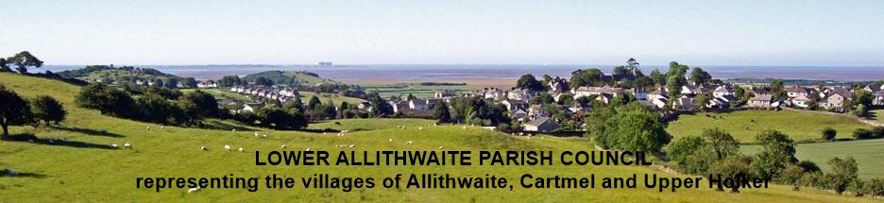

**Allithwaite and Cartmel**

**Neighbourhood Development Plan**

**Regulation 14 Consultation on the Draft Plan**

**6th September – 30th October 2021**

**Introduction**  
Thank you for supporting development of a Neighbourhood Plan for Allithwaite and Cartmel, which will help to influence future development of our parish and three villages.

This survey will seek your views on the pre-submission draft of our Neighbourhood Plan, the Regulation 14 Version. The questions below ask for your feedback on each individual policy within the plan. The full document is available to view on the Parish Council website <http://Allithwaiteandcartmel-nplan.co.uk>, in hard copy fromthe Village Hall or by contacting Julie Hendry, Parish Clerk by email: [acpc.clerk@gmail.com](mailto:acpc.clerk@gmail.com).

**How the information from this consultation with be used**

Information given on this form will be used to help prepare the final Allithwaite and Cartmel Neighbourhood Plan for examination. Please be aware that the forms will be shared with the Parish Council’s Planning Consultants and your comments may be made publicly available, for example, if a challenge is made regarding the validity of responses.

Please use this form for your comments and submit your response in one of the following ways:

* Email as an attachment to: [mikelamb34th@gmail.com](mailto:mikelamb34th@gmail.com) Chairman of the Steering Group.
* Post copies to: Mike Lamb, 6 Hazelgarth, Allithwaite, Cumbria LA11 7RS.
* Complete the survey online: [www.allithwaiteandcartmel-nplan.co.uk](http://www.allithwaiteandcartmel-nplan.co.uk).

**What happens next:**

After the closing date, we will consider the comments and the extent to which concerns can be addressed. The draft plan amended as necessary will then be submitted to South Lakeland District Council who will publicise the draft plan. This provides further opportunity for people to make representations about the plan’s proposals. The next stages following this will be:

* Submission of the draft plan for independent examination;
* Publication of the independent examiner’s report and decisions;
* A referendum of residents on the draft plan; and
* If the referendum result supports the draft plan it will ‘made’ and become part of the development plan.

**The closing date for comments is 12pm on 28th August 2021.**

**GENERAL COMMENTS**

|  |  |
| --- | --- |
| **I am generally in favour of the Plan**  **YES/NO** | **I would like to see changes to the Plan**  **YES/NO** |
| **Comments on the Plan overall:** | |

**COMMENTS ON POLICIES**

|  |  |  |  |
| --- | --- | --- | --- |
| Policy No. | Policy Name | Do you agree?  Delete as appropriate | Any comments you have on the policy |
| **Design Principles** | | | |
| **Policy AC1** | *Has taken account of the Allithwaite and Cartmel Parish Design Guide* | **YES/NO** |  |
| **Policy AC2** | *Development within Cartmel Conservation Area and its setting.* | **YES/NO** |  |

|  |  |  |  |
| --- | --- | --- | --- |
| **Natural Environment** | | | |
| **Policy AC3** | *Protecting and Enhancing Landscape Character around Allithwaite and Cartmel* | **YES/NO** |  |
| **Policy AC4** | *Protecting Local Green Space* | **YES/NO** |  |
| **Policy AC5** | *Protecting and Enhancing Green Infrastructure and Biodiversity* | **YES/NO** |  |
| **Policy AC6** | *Dark Skies* | **YES/NO** |  |
| **Policy AC7** | *Improving pedestrian movement.* | **YES/NO** |  |

|  |  |  |  |
| --- | --- | --- | --- |
| **Community Infrastructure** | | | |
| **Policy AC8** | *New Housing in Allithwaite and Cartmel* | **YES/NO** |  |
| **Policy AC9** | *Principal Residence Requirement* | **YES/NO** |  |
| **Policy AC10** | *Caravan and Chalet Parks* | **YES/NO** |  |
| **Policy AC11** | *Maintaining and Enhancing Community facilities and Infrastructure.* | **YES/NO** |  |