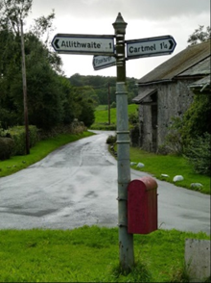**Allithwaite and Cartmel**

**Draft Neighbourhood Plan**

**Public Consultation**

**6th September – 30th October 2021**

**Representation Form**

**PLEASE COMPLETE AND RETURN ONE FORM FOR EVERY COMMENT MADE**

|  |
| --- |
| **Office Use Only**  Consultee No.  Representation No. |

|  |  |
| --- | --- |
| Name |  |
| Organisation |  |
| Address |  |
| Email |  |
| Tel. No. |  |

To which part of the Draft Allithwaite and Cartmel Neighbourhood Development Plan does your representation refer?

|  |  |
| --- | --- |
| Page Number |  |
| Paragraph Number |  |
| Policy Number |  |

Are you supporting, objecting, or making a comment? (Please Tick )

|  |  |
| --- | --- |
| Support |  |
| Object |  |
| Making a Comment |  |

Please use the box below and overleaf for any comments.

|  |
| --- |
|  |

**Data Protection:** The information you supply will be processed by the Allithwaite and Cartmel Neighbourhood Plan Steering Group who will analyse the comments on behalf of the Allithwaite and Cartmel Parish Council. Any personal information you provide will be treated as strictly confidential and it will be used for the purposes of informing the Allithwaite and Cartmel Neighbourhood Plan. This personal information will be passed to South Lakeland District Council in accordance with the Neighbourhood Planning regulations to enable them to consult you again at the Regulation 16 stage. The comments you provide will appear in full in the published Consultation Statement.

**Thank you for your time and interest.**

**Please return this form by 12pm on 28th August 2021 to:**

**Mike Lamb**

**6 Hazelgarth**

**Allithwaite**

**Cumbria LA11 7RS**

**or email:**

**acpc.clerk@gmail.com**